# Data Representation

## Lab 5.1: CURL

## (NOTE: experienced some errors for the final 2 Questions when copied and pasted the code from the lab, made some adjustments and the code ran and gave the correct output)

1. Test to see if CURL is working from you command line.

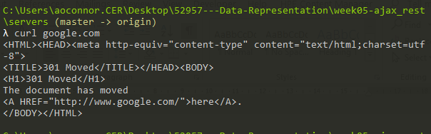

1. You can check this by using the –i option

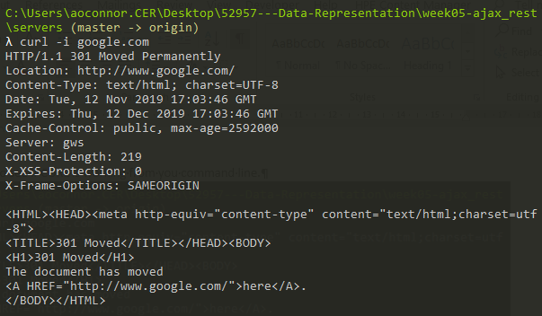

1. Look at the website http://dummy.restapiexample.com/

a. What the curl command be to view all the employees?

b. What would the curl command be to view employee 2202?

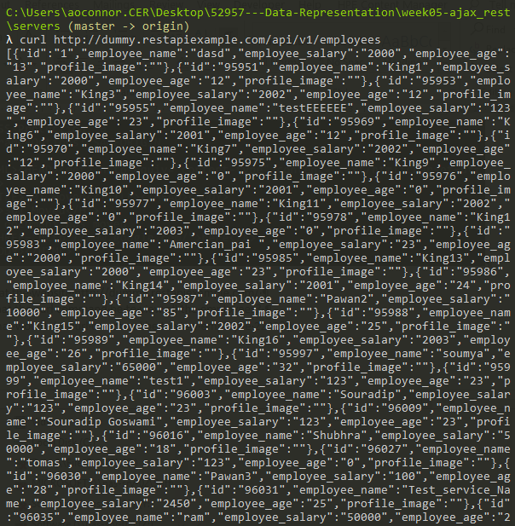

b.

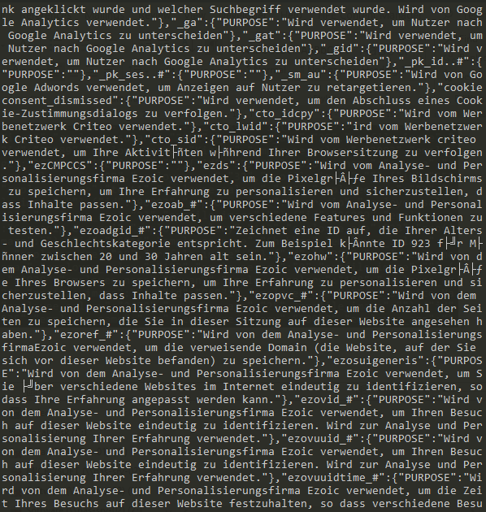

4. For the same web site how would you use curl to delete an employee

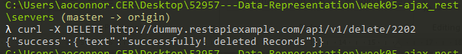

5. For the same website how would you use curl to create an employee, you may need to make the employee name unique

1. Mac – I do not own a Mac computer

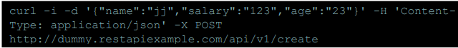

b. Windows (windows only has “ (no ‘) so the data needs to be between “ “ and all the inverted commas in the JSON need to be escaped \”. (This is a pain)

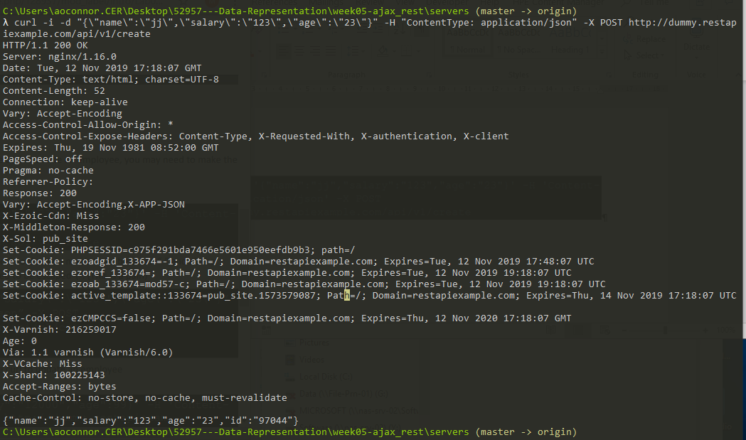

6. For the same website how would you use curl to update an employee

a. Mac – I do not own a mac

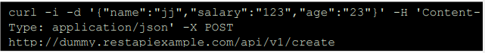

b.Windows

